***USE CASE DIAGRAM:***

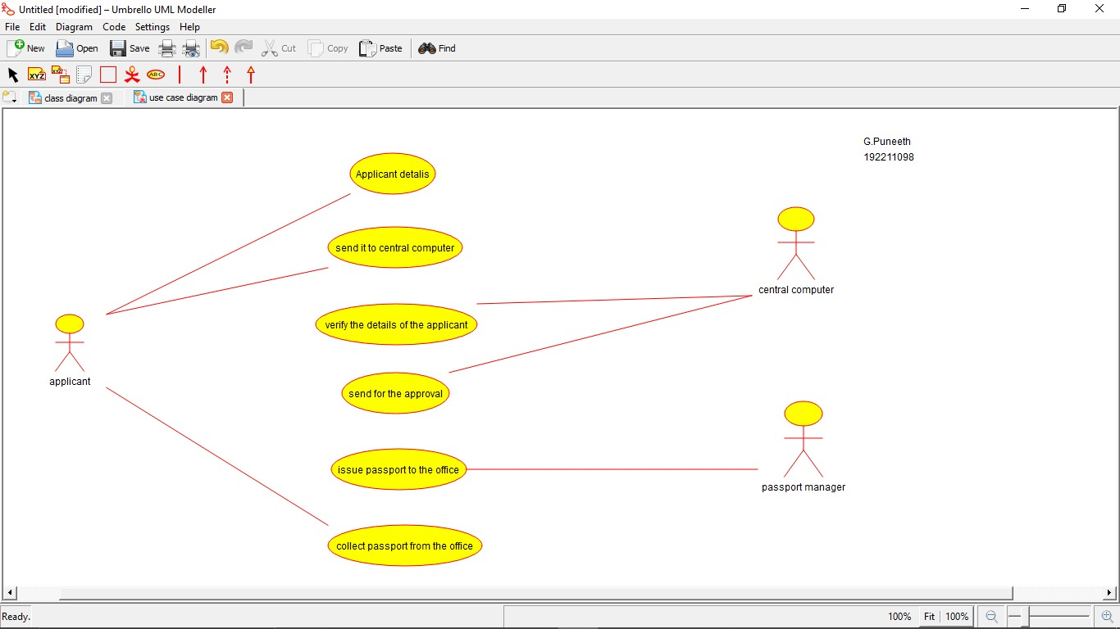

***ACTIVITY DIAGRAM:***

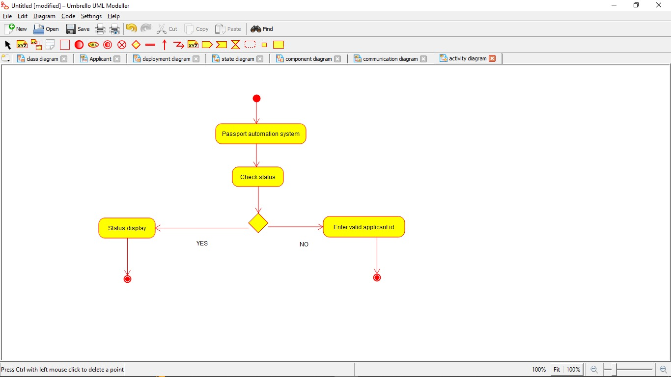

***CLASS DIAGRAM:***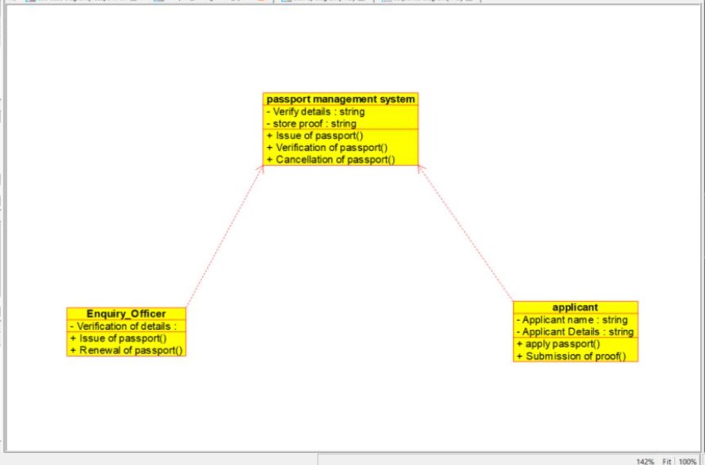

***STATE DIAGRAM:***

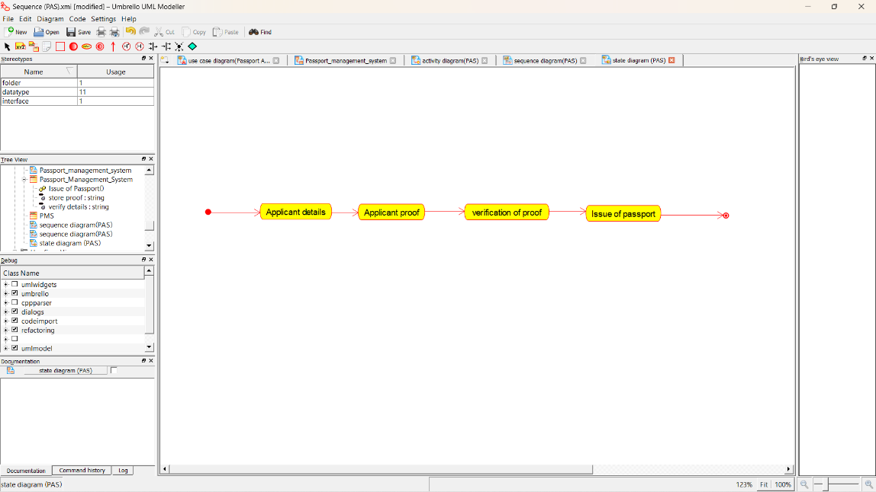

***SEQUENCE DIAGRAM:***

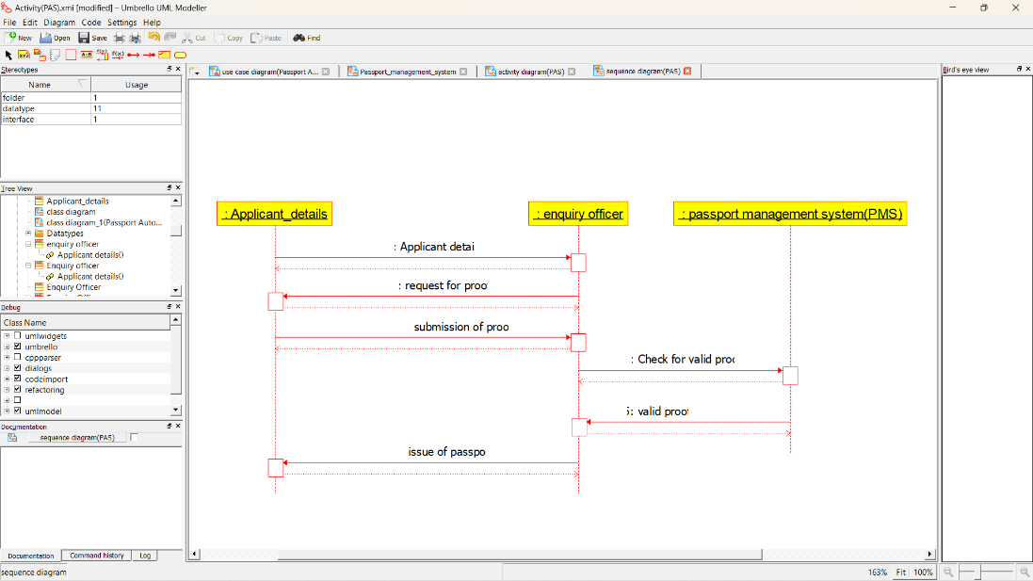

***COLLABORATION DIAGRAM:***

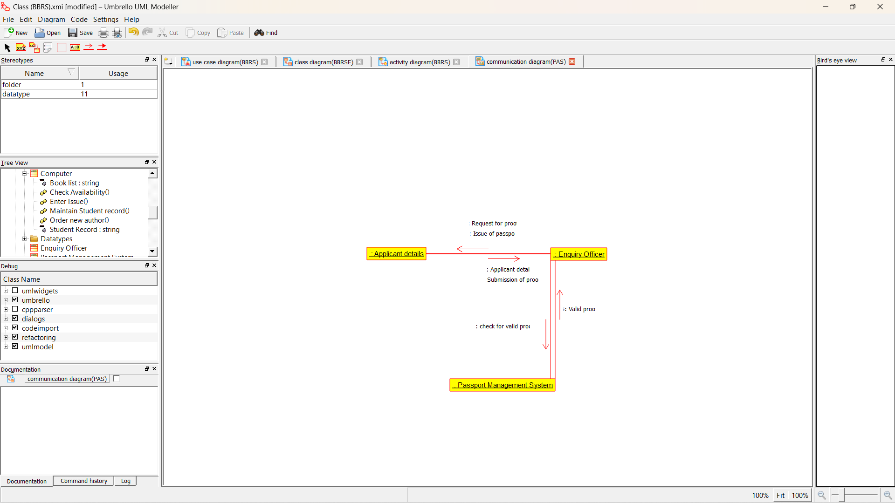

***COMPONENT DIAGRAM:***

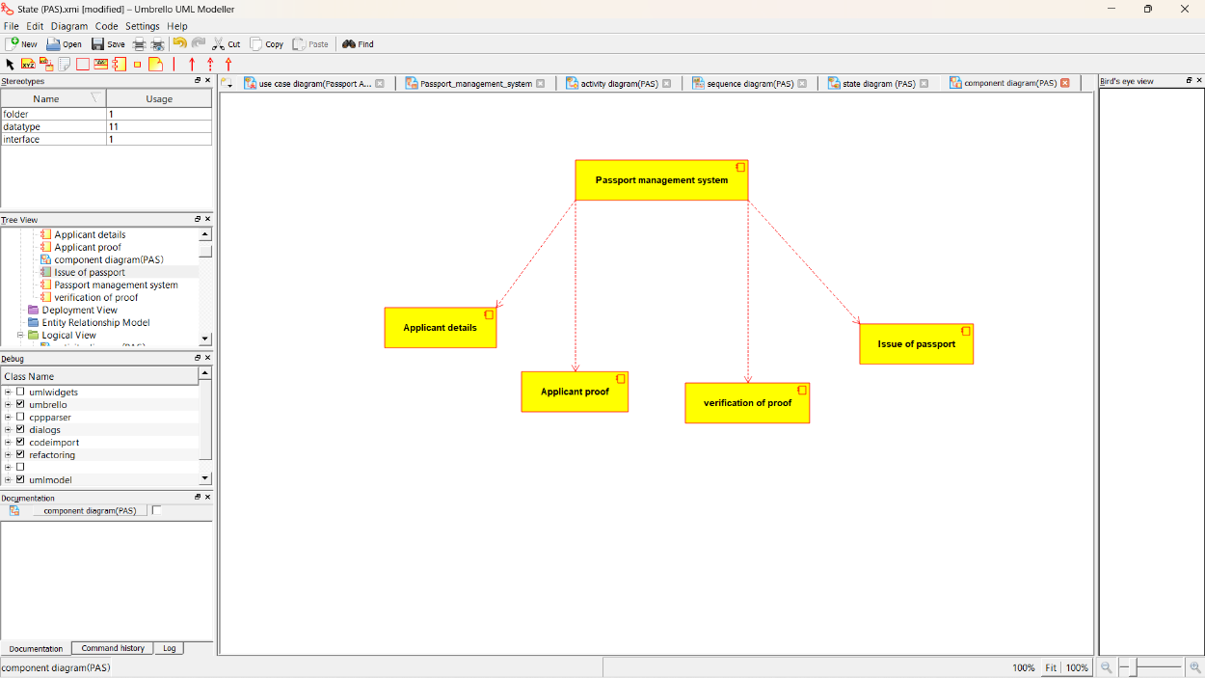

***DEPLOYMENT DIAGRAM:***